TWO knowledge points:
1 Please describe the differences among the classical software models, that is, the waterfall model, Incremental development, Integration and configuration. Especially, describe the advantages and disadvantages of them.
Waterfall Model
- the most basic software development life cycle process which is followed broadly in the industry.
- Requirement gathering and analysis phase, software design, programmed implementation and testing, maintenance.
Advantages | Disadvantages
- Simple and easy to understand and use.  - Easy to manage due to the rigidity of the model.  - Phases are processed and completed one at a time.  - Works well for smaller projects where requirements are very well understood.  - Clearly defined stages.  - Well understood milestones.  - Easy to arrange tasks. | - No working software is produced until late during the life cycle.  - High amounts of risk and uncertainty.  - Not a good model for complex and object-oriented projects.  - Poor model for long and ongoing projects.

Incremental development is done by joining two or more modules that are logically related. Then the other related modules are added and tested for the proper functioning. The process continues until all of the modules are joined and tested successfully.
- Incremental Approach, in turn, is carried out by two different Methods:

Bottom-up Integration

Top-down Integration

Advantages | Disadvantages
- Deliver working software early: with the first completed module (iteration).  - Parallel development.  - Modules can be completed at different times.  - Separation of concerns.  - Adaptable to changes in scope.  - Risks can be identified and addressed per module. | - Rectifying a problem in one unit requires correction in all the units and consumes a lot of time

integration testing is a type of testing where software modules are integrated logically and tested as a group.
- The purpose of this level of testing is to expose defects in the interaction between these software modules when they are integrated.

Advantages | Disadvantages
- Deliver working software early: with the first completed module (iteration).  - Parallel development.  - Modules can be completed at different times.  - Separation of concerns.  - Adaptable to changes in scope.  - Risks can be identified and addressed per module. | - Time taken for the whole process is more.  - the process of testing does not finish till all the modules of both the top and the bottom levels are included and tested.  - Drivers are necessary to call the high-level modules.

Configuration is the task of tracking and controlling changes in the software, part of the larger cross-disciplinary field of configuration management.It cover changes typically made by a system administrator which can be an advantage or a disadvantage in different cases.

Advantages | Disadvantages
- can help propel you to see your situation from different perspectives and find approaches to succeed that you might not otherwise have found. | - can blind you from the necessity to keep searching for better ways to pursue success.

2. Please describe how to understand the general model of the design process

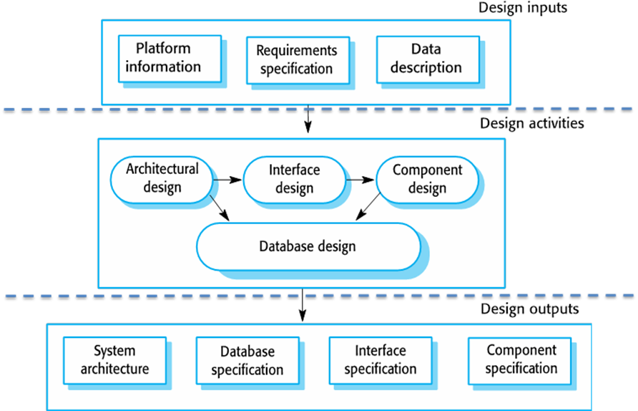
The Design Process is an approach for breaking down a large project into manageable chunks. Architects, engineers, scientists, and other thinkers use the design process to solve a variety of problems. Using this process to define the steps needed to tackle each project, and remember to hold to all of the ideas and sketches throughout the process.

